A-Z Covers LLC Rear Door Zipper Screen Overview.
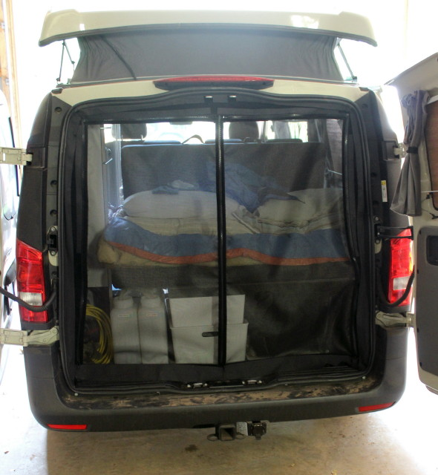
Step 6. fold the hook tape sticking out from under the gasket toward the rear of the van and stick the loop frame of the screen to the hook tape.
Step 3-4-5. Hook tape stuck to ½” loop tape installed under the gasket.
Step 1. Remove gasket from one side to the other and lay on floor.
Step 2. Clean the metal gasket flange with rubbing alcohol
Cut around door latches and stays.
If you do not have experience or are not comfortable working on the body of your van. Please take it to a reputable auto body, RV, or aftermarket installation shop.
A-Z Covers LLC Velcro Under the Gasket System. USA Patent Pending
Loop is the soft fuzzy half of Velcro Hook is the harder stiff half of Velcro

- Remove the door gasket from one side of the step to the other side of the step, let it lay on the shop floor, or a drop cloth.
- Clean the gasket flange with rubbing alcohol or mild solvent to clean any glue or grime off.
- Stick the ½” loop adhesive backed Velcro to the inside of the metal gasket flange, were the gasket rides.
- Stick the Hook Velcro tape provided to the loop you just stuck onto the gasket flange, slightly overlapping the edge of the metal flange.
- Carefully reinstall the gasket over the two pieces of Velcro you just stuck onto the gasket flange, use care, you may have to spread the gap between the gasket with a flat screwdriver, using a rubber hammer lightly tap the gasket back onto the flange.
- BEND! The hook tape down, now the smooth side of the tape will be facing outside the van and stick the Loop frame of the screen to the Hook tape facing the inside of the van. On the corners put a couple of small cuts to allow the hook tape to lay flat.
www.a-zcovers.com links to our You Tube Channel with product and installation videos. https://www.youtube.com/channel/UCa0HaXHJfrh1EmXx48CIC
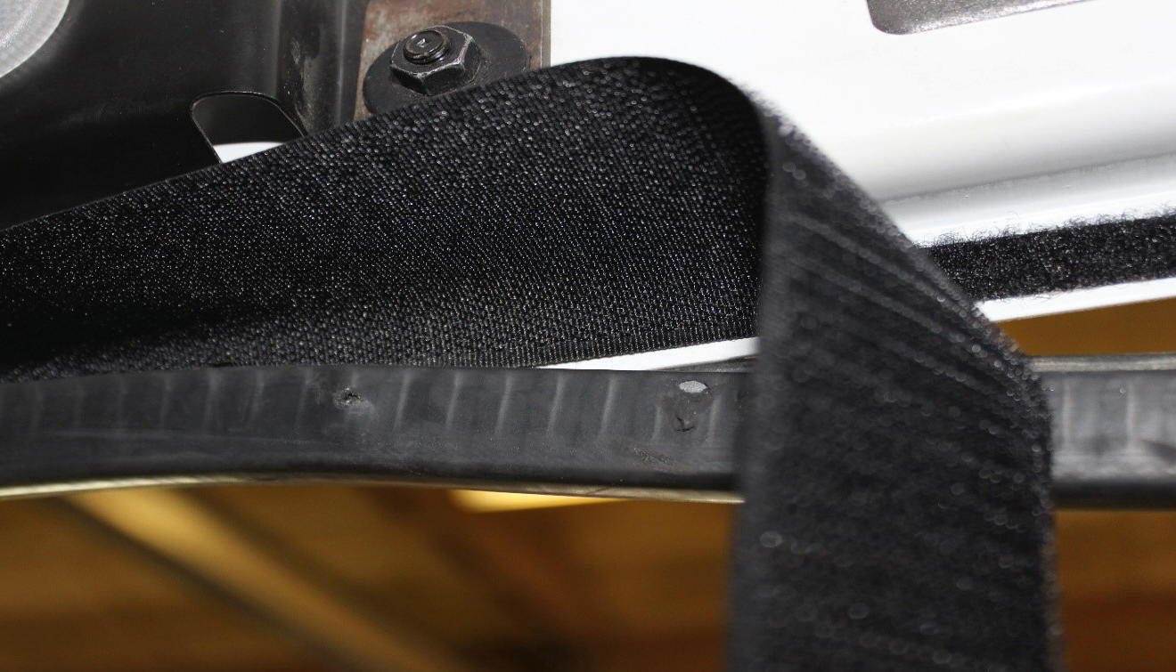
Shows the backside (smooth) of the hook tape being installed under the gasket. After installed fold it down and stick the screen to it. Cut hook tape at corners in a couple places so it will lay flat.
Shows the gasket being reinstalled over the hook tape and the loop adhesive onto the metal gasket flange. On vans with plastic trim the wider hook tape provided gets folded into the extra rubber flap that is attached to the gasket leaving about an inch sticking out from behind the plastic trim.
Shows the ½” Loop adhesive backed tape to the inside of the metal of the gasket flange, with the gasket pulled loose.
The picture above shows how the gasket is reinstalled over the loop and the hook installed onto the gasket flange. One tip that helps this process along, is slightly overlapping the hook tape just over the edge of the metal flange, so when you push the gasket back on it does not push the hook tape off of the loop you stick to the metal flange.
Interior Plastic trim that is covered by the rubber gasket flap.
After the gasket is installed over top of the hook tape, simply fold it toward the opening of the door and stick the screen to it. On vans with plastic trim panels and an additional rubber flap on the gasket. For these vans we provide a wider 3” hook tape and it gets installed the same way, except you fold it in the rubber groove that covers the plastic trim, and the end result will be about one inch of hook sticking out from under the edge of the rubber flap on the gasket and the plastic trim panel.
www.a-zcovers.com s.knoll@hotmail.com 208-449-7112
All products come with a one-year limited warranty against manufacturer defects. Does not include damage! This warranty only covers the cutting and sewing of the product. We do not manufacture the material it is made of. E-mail to request a warranty claim along with a copy of your receipt. Once it is returned if it is deemed as a manufacturer defect, it will be repaired.

