Cab & Cargo Insulation Set.
- Slide the windshield piece between the glass and the dash. Carefully wrap it around the mirror, slide the top under the edge of the headliner, small pieces of Velcro can be used on the top of the windshield, and the visors can be used to hold it in place.
- Hold the side windows in place marking where you want to put a few small pieces of Velcro ½” x 1”. Make sure you clean the area with rubbing alcohol before sticking it in place. Insulation manufacturer recommends using aluminum reflective duct tape for repairing any holes put in the reflective area. Use the same install method on a cargo set.
- Picture shows a Wood Grain set, with our NEW 12 pc. Micro Magnet set now included on all cab sets. Magnet sets are a nice option on some Cargo sets. There must be metal around the window for the magnet sets to work in the cargo area, and you may need more than 6 magnets to hold a cargo window in place.
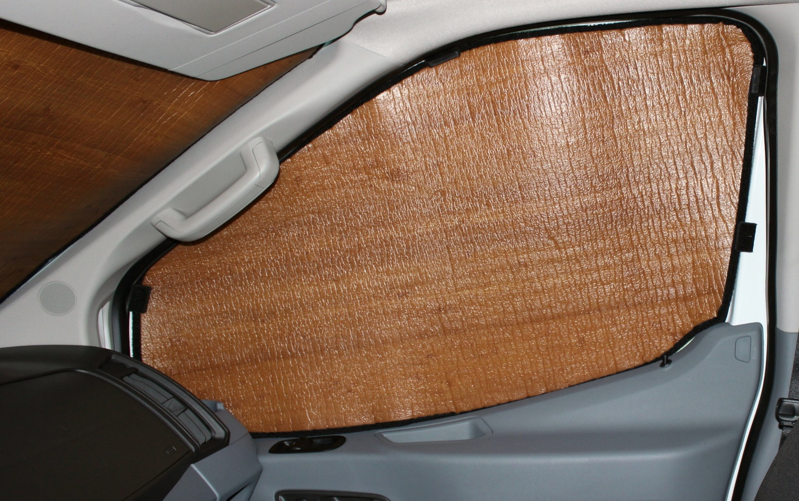
½” x 1” piece of Velcro in 5 places will hold shade in place.
Shows our new micro magnet set. No more Velcro stuck around your windows.
Please visit our website and click on the link to our You Tube channel to see a Cab Insulation set installed. Same process is used to install your cargo area set.

All products come with a one-year limited warranty against manufacturer defects. Does not include damage! This warranty only covers the cutting and sewing of the product. We do not manufacture the material it is made of. E-mail to request a warranty claim along with a copy of your receipt. Once it is returned if it is deemed as a manufacturer defect, it will be repaired.
www.a-zcovers.com s.knoll@hotmail.com e-mail 208-449-7112 phone

