A-Z Covers LLC Rear Door Magnet Screen.
If you do not have experience or are not comfortable working on the body of your van. Please take it to a reputable auto body, RV, or aftermarket installation shop.
A-Z Covers LLC Velcro Under the Gasket System. USA Patent Pending
Step 3-4-5. Hook tape stuck to ½” loop tape installed under the gasket.
Step 9-10. Shows the Hook sweep stuck to the screen and the metal strip covered in loop, sticks to the hook sweep and the metal strip sticks to the magnet strip you stick to the van floor.
Step 1. Remove gasket and lay on step or floor.
Step 2. Clean gasket flange with rubbing alcohol or solvent.
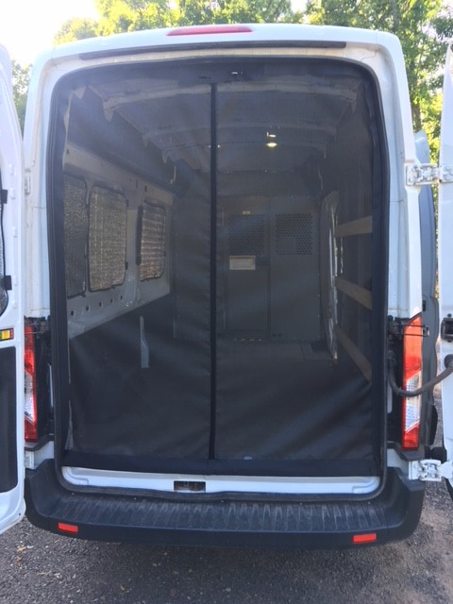
Step 11. Cut slits on radius and cut for door latches and stays
Step 7-8. Install the two mating magnet strips hook tape to the loop binding on the screen and wrap each of them with the 2” hook tape the screen came shipped with.
Loop is the soft fuzzy half of Velcro Hook is the harder stiff half of Velcro

A-Z Covers LLC Velcro Under the Gasket System. USA Patent Pending

- Remove the door gasket from one side of the step to the other side of the step, let it lay on the shop floor, or a drop cloth.
- Clean the gasket flange with rubbing alcohol or mild solvent to clean any glue or grime off.
- Stick the ½” loop adhesive backed Velcro to the inside of the metal gasket flange, were the gasket rides.
- Stick the Hook Velcro tape provided to the loop you just stuck onto the gasket flange, slightly overlapping the edge of the metal flange. The wide piece of hook in your set is used to cover the latch strikers. Promasters have to stick adhesive backed hook on backside of door strikers. Use the 3” hook tape provided from the latch areas down to the step areas.
- Carefully reinstall the gasket over the two pieces of Velcro you just stuck onto the gasket flange, use care, you may have to spread the gap between the gasket with a flat screwdriver, using a rubber hammer lightly tap the gasket back onto the flange.
- BEND! The hook tape down, or to the middle of the door opening, now the smooth side of the tape will be facing outside the van and stick the Loop frame of the screen to the Hook tape facing the inside of the van. On the corners put a couple of small cuts to allow the hook tape to lay flat.
- Remove the 2” hook tape that is stuck to the outside and inside of the screen.
- Stick the two mating magnet strips to the vertical seam you just removed the 2” hook tape from. Now stick those two mating magnet strips to the loop on the edge of the screen and wrap them with the 2” hook tape to encapsulate each magnet strip on each side with the hook tape.
- Clean the floor just in front of the doors when they are closed and stick the adhesive backed loop to the floor and stick the hook side of the two magnet strips to each sides loop that is on the floor.
- Install the two loop covered metal strips to the Hook sweep that is stuck to the bottom of the screen.
- Cut hook tape to allow clearance for door latches and door stays, cut hook slits in tape on corners so it will lay flat. 6 ft. 1” hook tape provided is to be cut for rolling and tying the screen to the sides.
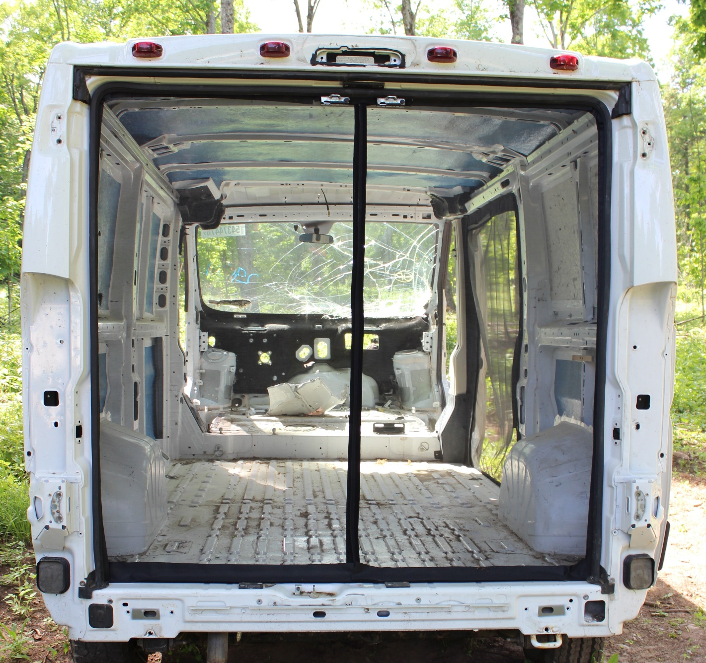
Shows a Low Roof Ram Promaster. Cut the hook tape to get around these 2 strikers and use the 1” hook tape and plastic primer to stick the hook tape on the plastic trim on the backside of the strikers, and use the loop binding on the screen edge to stick to the hook adhesive tape on the backside.
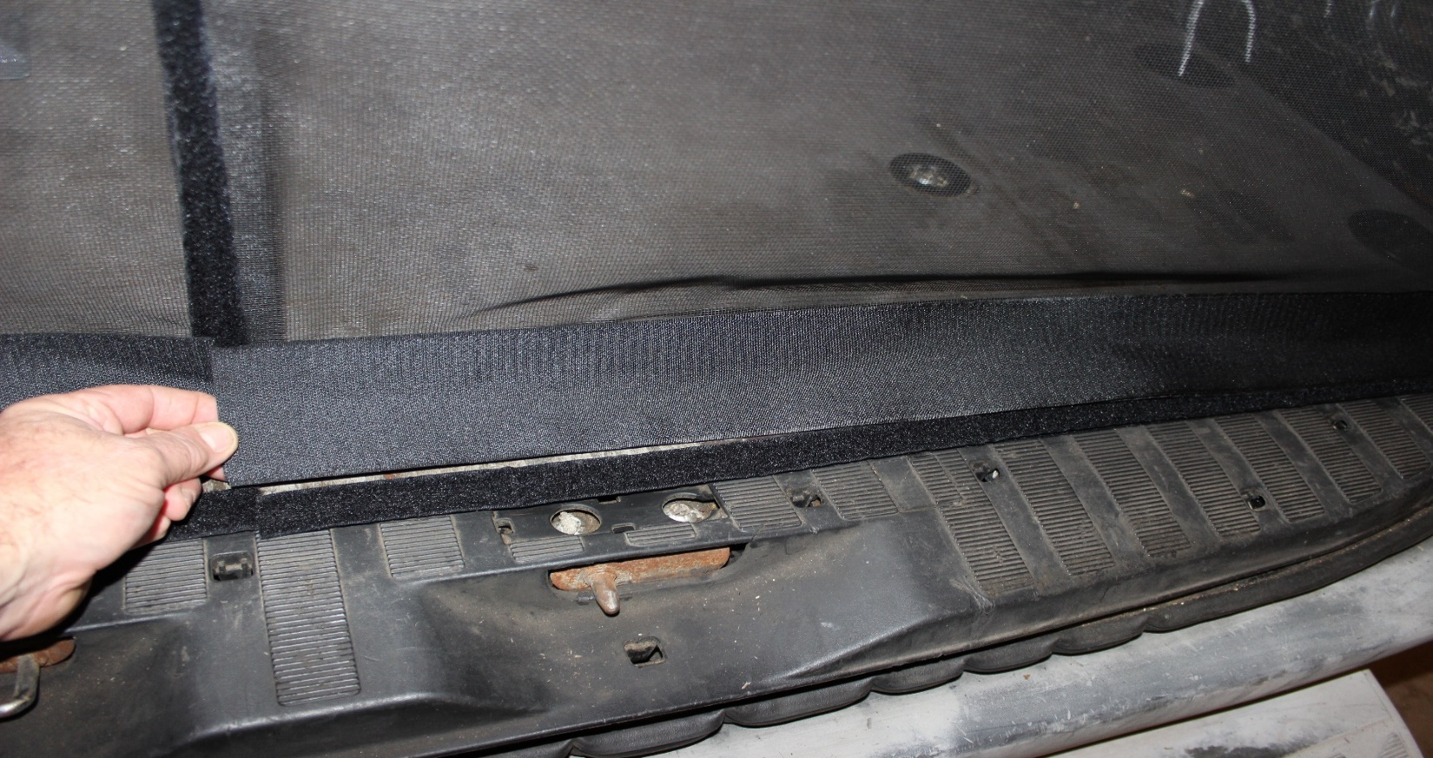
Close up of sweep and vertical magnet metal strip.
Magnet strip stuck to the ½” loop stuck to the sill plate. Above it shows the outside of the sweep material and on the opposite side of the sweep you stick the straightened out metal strip.
Show magnet strips stuck together, separate them and wrap them with the 2” hook tape that the screen came shipped with, stuck to the front and the back.
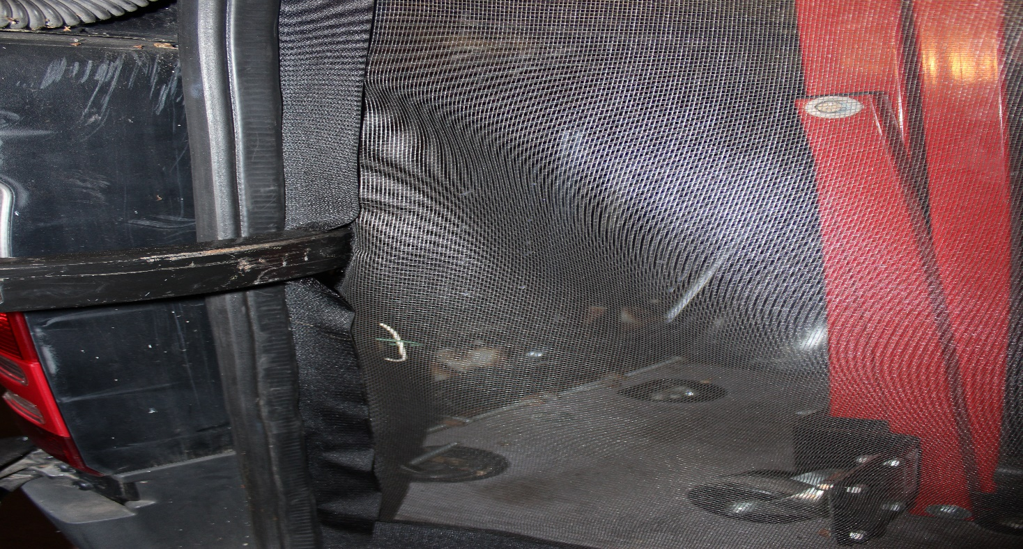
Showing hook tape, sticking out from under the gasket, and how you need to cut that tape to allow the door stays to pass through it.

www.a-zcovers.com links to our You Tube Channel with product and installation videos. https://www.youtube.com/channel/UCa0HaXHJfrh1EmXx48CIC

One-year limited warranty on sewing and assembly defects. Does not include damage! The product will have to be sent back to the manufacturer and if it is deemed as a manufacturer defect, it will be repaired or if it cannot a replacement will be sent.
A-Z Covers LLC s.knoll@hotmail.com e-mail 208-449-7112 phone

